Name: World History - B
Date:
Name and date are required! You will lose points if you leave them off!
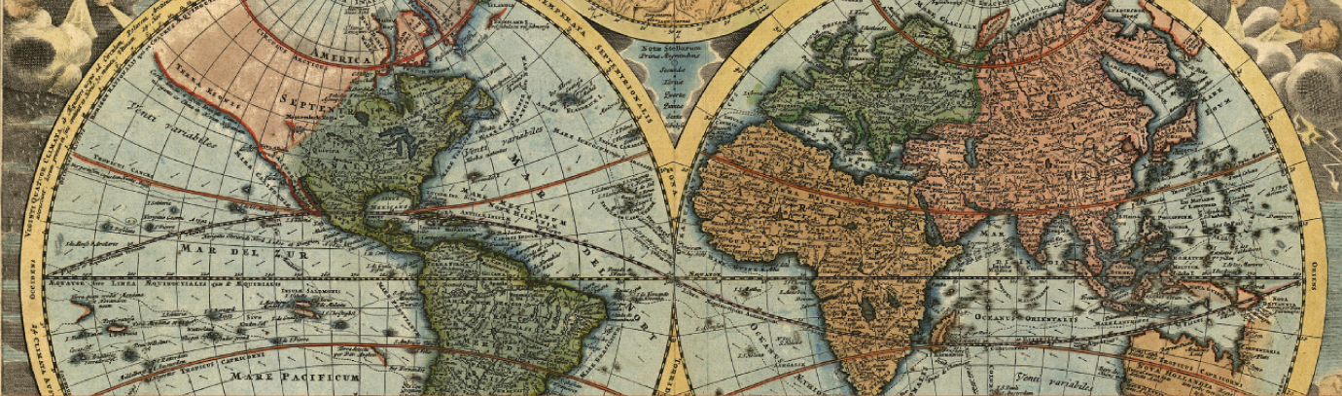
Unit 8 Section 3
Course overview: World History is a survey course covering from early civilizations to modern times, with emphasis on the political and philosophical roots of western democracy. Topics include: the rise of democratic governments; political, social and economic developments of the Middle Ages; the Renaissance and era of discovery; the growth of democracy and nationalism; the industrial revolution; and the two world wars. Postwar problems and recent developments are also studied.

CA State Standards:

10.7 Students analyze the rise of totalitarian governments after World War I.

1.Understand the causes and consequences of the Russian Revolution, including Lenin’s use of totalitarian means to seize and maintain control (e.g., the Gulag).
2.Trace Stalin’s rise to power in the Soviet Union and the connection between economic policies, political policies, the absence of a free press, and systematic violations of human rights (e.g., the Terror Famine in Ukraine).
3.Analyze the rise, aggression, and human costs of totalitarian regimes (Fascist and Communist) in Germany, Italy, and the Soviet Union, noting especially their common and dissimilar traits.

Assignments:
Chapter 28 Lesson 1: Instability After World War I
Worksheet: Economics and the Great Depression
Worksheet: Lenin's New Economic Policy
Chapter 28 Lesson 2: The Rise of Dictatorial Regimes
Worksheet: Fascist Propaganda
Worksheet: Benito Mussolini
Worksheet: Joseph Stalin
Chapter 28 Lesson 3: Hitler and Nazi Germany
Worksheet: The Message of Nazism
Worksheet: Lebensraum Expansion
Check-in 8.3
Unit 8 Test

Packet Directions
- These packets are assessed coursework.
- You will be scored based upon completion, effort, and accuracy.
- All short answer questions are to be completed IN YOUR OWN WORDS! Answers copied from online sources will not receive credit
Unless a question specifically asks you to cite or quote from the text, answers copied word for word or cut and pasted from the online text (even with quotations) will be treated as copied and marked down. (See Inspire’s plagiarism policy in your course syllabus)
- When typing your responses please keep your answers in red font (when red font is provided)
- Packets are required to be uploaded as one whole unit and as one file (see the syllabus for details)
- Name and date are required! You will lose points if you leave them off!

-Content Vocabulary-
Directions: Use the textbook’s glossary to complete vocabulary words as you complete the unit. Looking them up online often gets you the wrong definition!
Depression | This is the severe and prolonged downturn in economic activity.
Deficit spending | It is an intentional excess spending meant to stimulate the economy
Surrealism | This is movement particularly in visual art and literature, flourishing in Europe between World war I and II
Totalitarian state | A government that subordinates the individual to the state and strictly controls all aspects of life by through intimidating measures.
Fascism | A political ideology usually characterized by nationalism& authoritarianism
Collectivism | It’s any of several types of social organization in which the individual is seen as being subordinate to a social collectivity such as a state, a nation, a race or rather A social class
Nazi | The member of the National Socialist German Workers' Party.
Concentration camp | Refers to a place in which people are detained or confined, usually under harsh conditions and without regard to legal norms of arrest.
Aryan | A member of the ancient Aryan people.

-Don’t forget about Key Assignment #8 due by 4/21-

-Chapter 28 Lesson 1: Instability after World War I-
Directions: Read each main idea and answer the questions below. Refer to your textbook to write the answers.

A. Main Idea: After World War I, European nations renounced war, but several problems made keeping the peace difficult.
1. What problems threatened the peace after World War I?
Answer: United States refusing to join the League of Nations and reparations
2. a) How does your textbook define inflation (p.563)? b) Why was Germany experiencing inflation?
c) In 1914 how many German marks = 1 U.S. dollar, d) by 1923 how many German marks = 1 U.S. dollar?

Answer a):It defines it as the rise in the general level of prices where a unit of currency effectively buys less than it did in prior periods.
Answer b): The German governments increased the money supply in order to cover the soaring costs, initially of the war itself, and afterwards, of the heavy reparations that the Allies had imposed on Germany in the Treaty of Versailles.
Answer c): 4.2
Answer d): 4,200 billion German marks
3. How did the Dawes Plan affect Europe?
Answer: It reduced reparations, then coordinated Germany's annual payments, gave them 200 million loan, which led to brief prosperity
in Europe.
4. What international treaties supported peace after World War I?
Answer: Treaty of Locarno and Kellogg-Briand Pact
B. Main Idea: The world economy collapsed during the Great Depression.
1. a) When did the international economy collapse, and b) why?
Answer a): 1930
Answer b): Because of the US stock market crash.
C. Main Idea: The economic crisis of the Great Depression challenged governments in Europe and the United States.
1. What were three immediate effects of the Great Depression?
Answer: The immediate effects of the Great Depression include;The major decline of personal and household income in the US, Escalating poverty and leaving families with little to nothing. This led to subsequent losses in government tax revenue as well.
2. How did the Great Depression affect Germany and France?
Answer: It hurt them economically and experienced runaway inflation and over 4 million unemployment
3. What program of active government intervention addressed the Great Depression, and how did it avert a social revolution in the United States?

Answer: The New Deal - increased public works. It put people to work and supported them with welfare and social security funds

D. Main Idea: Science and art in the 1920s and 1930s reflected the uncertainties of the interwar years.
1. How did science and art develop after World War I?
Answer: Artists embraced the surreal and irrational in their work. Physicist Werner Heisenberg's uncertainty principle challenged Newtonian physics.
2. a) What is the uncertainty principle based on? b) Why did the textbook state that the Heisenberg uncertainty principle “fit
in well” during these interwar years?

Answer a): It’s based on the idea that the position and the velocity of an object cannot both be measured exactly, at the same time, even in theory.
Answer b): This is due to the fact that all physical laws are based on uncertainty,as aresult,the theory's emphasis on randomness challenges Newtonian physics & in a way represents new worldview.
Summary & Reflection

Directions: Using ideas from throughout the entire lesson, summarize the main ideas by answering the question below. Answers must be IN YOUR OWN WORDS. DO NOT RESEARCH ANSWERS ONLINE! Points awarded based on accuracy and effort.

Paving the way to World War II
Explain what happened in the following situations and how they could contribute to the outbreak of war in the future.
German Reparations/ French invasion of the Ruhr: This was an error in which the French and Belgian armies sent 60,000 soldiers into the Ruhr region of Germany with an aim of extracting the unpaid reparations and take control of key industries and natural resources. By virtue of invading another country’s without any legal criteria can likely cause war among countries.
Great Depression/unemployment in Europe:As a worldwide economic downturn that began in 1929 and lasted until about 1939,the great depression shaked the world to alevel that most people in Europe drastically lost their jobs.for example unemployment rocketed to over six million people around one-fifth of the German working population, and the extremist political parties.Failure by governments to empower their people well might likely cause another economic depression.
Rise of extremist political parties throughout Europe/ erosion of democracy:
Populist extremist parties presented one of the most pressing challenges to European democracies. As a result, Parties such as the Front National in France, Sweden Democrats and Austrian Freedom Party continue to rally large and durable levels of support. As an approach to ensure this doest happen ,there is need to examine what is causing citizens across Europe to shift support behind populist extremists and recommends how mainstream political parties can respond to the challenge

-Worksheet: Economics and the Great Depression-
Economics and the Great Depression
Although brief prosperity followed the end of World War I, the economy eventually collapsed, and a period of depression began in Europe and the United States. This in turn caused people to doubt democracy and look to alternatives.

Business cycles fluctuate between periods of recession and expansion and are marked by changes in the gross domestic product, or GDP. A recession begins after a financial peak in the economy and ends when it reaches a trough, or the lowest point. This is when people usually experience the hardest times. However, a trough also indicates a turnaround point in which the economy will start to recover.

A recession that lasts a long time or becomes very severe is often classified as a depression. At least two important factors led to the depression in the 1930s, which would later be called the Great Depression. The first was a series of monetary slumps in various countries during the late 1920s. The second was a global financial crisis triggered by the crash of the U.S. stock market in October 1929.

The Great Depression had profound effects around the world. In the United States, the unemployment rate skyrocketed, remaining at over 20 percent for four consecutive years between 1932 and 1935. Between 1929 and 1932, the decrease in industrial production exceeded 50 percent in numerous industries, including iron and steel, shipbuilding, and automobiles.

In Germany after the crash, loans were withdrawn by panicked Americans. As a result, German stock exchanges dropped as well, with businesses and companies failing at an alarming rate. In 1930 unemployment numbered 3 million and doubled to 6 million by 1932. Trade fell by two-thirds and Germany’s industry was operating at less than 50 percent. This economic devastation undermined many people’s faith in democracy and predisposed them to accept the simple solutions offered by politicians in quest of dictatorial power, such as Adolf Hitler in Germany.

Directions: Use the preceding text to answer the questions below. Remember: answers need to be in your own words
1. Explaining: What factors (list more than one) brought about the Great Depression?
Answer: i). 1929 Stock Market Crash; this happened when the Dow Jones Industrial Average dropped 11%. Panicked investors began selling their shares in an unprecedented volume; the Dow had been gradually declining since its peak in early September of that year and investors feared the worst.
ii).The introduction of Smoot-Hawley Tariff Act; this act was meant to help protect America's farmers from overseas competition by putting in a protectionist policy, but it backfired tremendously.
2. Drawing Conclusions: What are the positives and negatives for people when the economy hits a trough?
Answer for the positives: when the economy enters a recession is that it brings an abrupt stop to inflation produced by price speculation. This brings a true panorama of the cost of overall goods and services.
Answer for the negatives: when the economy enters a recession is that businesses tend to reduce their output due to the decrease in the demand for goods. This leads to unemployment, as the current workforces are no longer needed to satisfy the current demand.
3. Analyzing: Why did some people turn toward less democratic forms of government during this time?
Answer: This due to the idea that less democratic forms usually include economic means that are based on a command market system. Command markets are opposite of the free market systems and in a command system a government can choose what will be made and what sold and at what prices and this is usually useful for solving things like economic crises.

-Worksheet: Lenin’s New Economic Policy-
From 1918 to 1921, Russia’s economic policy of war communism was a disastrous failure. Hoarding, drought, and famine combined to create an economic crisis. The Kronshtadt Rebellion, an uprising of sailors and urban workers against the new Communist government, also influenced Russian leaders to modify their overall financial strategy.

In 1921 V.I. Lenin intervened and the country abruptly shifted gears. His New Economic Policy (NEP) was installed as a temporary measure to maintain the Communist Party’s hold on power. The policy was a modified form of capitalism. Whereas communism had rigidly enforced the collectivization of agriculture and industrial manufacturing, the NEP returned most agriculture, retail trade, and small-scale light industry to private ownership. The government continued to keep control of heavy industry, banking, transportation, and foreign trade. This concession to the peasantry was seen as an economic retreat from the financial reconstruction of 1920. Not everyone approved of this change. Infighting within factions of the divided Communist Party created additional conflict. Some opponents believed that the economy was strongly tied to the political order. They were worried that the removal of controls would undermine the party’s authority. This mixed economy, which Lenin had imagined in 1905 as capitalism dictated by the party, undermined the dream of pure socialism.

The NEP was seen as a step toward political moderation, which angered some Communists. However, this same step encouraged Western nations, including the United States, to think that the Russian government was becoming less radical. The New Economic Policy was initially successful. However, at its outset, millions of Russians still suffered from starvation and disease epidemics. Through certain “respectable” figures in the fledgling government, Lenin appealed to foreign nations for aid. He also asked capitalists from those countries—as well as his own—to help form the Soviet economy. Many within the Communist Party saw this as a move away from the ideas of the revolution, one of which was that a battle between capitalism and socialism was unavoidable.

After Lenin’s death in 1924, the Soviet leadership was split over the policy. Although the NEP had effectively rescued the Soviet Union from the brink of economic collapse, it was never intended to be permanent. Finally, in 1928, Joseph Stalin, who had risen to become the Soviet Union’s most powerful leader, eliminated private ownership of farmland, signaling a return to the policy of collectivization.

Directions: Use the preceding text to answer the questions below. Remember: answers need to be in your own words
1. Why did Lenin implement the New Economic Policy (NEP)? (Include the Kronshtadt Rebellion in your response.)
Answer: He introduced NEP as an approach to enhance economic stability that later allowed the Soviet people to recover from years of war, civil war, and governmental mismanagement. Consequently, the Kronshtadt Rebellion of March 1921 further convinced the Communist Party and its leader of the need to retreat from socialist policies in order to maintain the party’s hold on power.
2. Analyzing Information: Why were so many Communist Party members against the NEP?
Answer: Many Communist Party members considered this as an exploitation of urban consumers.
3. Drawing Conclusions: While people often link Lenin with Stalin, how does Lenin’s approach to Russia’s economic problems
show a distinct difference between the two leaders? Cite evidence from this article

Answer: Lenin characterized the NEP in 1922 as an economic system that would include a free market and capitalism, both subject to state control, while socialized state enterprises would operate on a profit basis which was absolutely in contrary to Stalin approach
-Chapter 28 Lesson 2: The Rise of Dictatorial Regimes-
Directions: Read the lesson and complete the outline below. Refer to your textbook to fill in the blanks.
I. The Rise of Dictators
From your textbook define: Totalitarian State: A government that subordinates the individual to the state and strictly controls all aspects of life by coercive measures
A. The only major European democracies left by 1939 were _France _ and _ Great Britain ; some states fell to dictatorial regimes, which wanted total control of their citizens.
B. Benito Mussolini’s political philosophy of fascism glorifies the States above the individual and emphasizes the need for a strong central government.
C. To control the Italian people, Mussolini gave the secret police unrestricted authority and used the media to spread propaganda.

II. From Russia to the USSR
A. After the Communist program was undermined by shortages caused by food hoarding and a severe drought, Lenin abandoned war communism in favor of his New Economic Policy .
B. In 1922, Lenin and the Communist party formally created a state known as the Union of Soviet Socialist Republics or by the initials USSR .
C. After Lenin died, a struggle began among the seven members of the Politburo, with Trotsky advocating for rapid industrialization and the end of the NEP.
D. Communist Party general secretary Joseph stalin removed the Bolsheviks from power, ended the NEP, and launched the first of several Five-Year for industrialization.
III. Authoritarian States in the West
A. Among the many regimes that arose in Eastern Europe after World War I, only Czechoslovakia , which had a large middle class, a liberal tradition, and a strong industrial base, maintained its political Democracy .
B. In Spain, General Franco led a revolt against the democratic government and created a military dictatorship that favored large landowners, businesspeople, and the Catholic clergy.
C. Franco's regime is an example of Authoritarian rule rather than totalitarian, because it did not attempt to control the everyday lives of its people.
Summary & Reflection

Directions: Using ideas from throughout the entire lesson, summarize the main ideas by answering the question below. Answers must be IN YOUR OWN WORDS. DO NOT RESEARCH ANSWERS ONLINE! Points awarded based on accuracy and effort.

Using the textbook’s definition of Totalitarian State, and examples provided by the textbook, explain how the following nations met the criteria of this definition (in other words, how did each of these governments attempt to control the 1) the political, 2) the economic, & 3) the social/ intellectual/cultural life of their people).

Italy
Attempted to control the political life of its people By appointing the mayors and also by giving veto powers over municipal decisions to provincial bodies that were strongly influenced by the provincial prefect, a government appointee
Attempted to control the economic life of its people by adopting what can be termed as economic fascism. This involved private ownership and government control of the economy. Individuals continued to own their property and their businesses, but without the right to do what they wanted

Attempted to control the social/intellectual/cultural life of its people by granting the popes a great deal of autonomy and were left with control over the legal and administrative system of Rome, including defense.
Russia/Soviet Union:
Attempted to control the political life of its people by reducing the number of political parties by mandating that they have at least 10,000 members and registered offices in at least half of Russia’s regions to compete in national elections.
Attempted to control the economic life of its people by issuing vouchers to Russian citizens that enabled them to purchase of shares in privatized firms, though in practice these vouchers frequently were sold for cash by entrepreneurs.
Attempted to control the social/intellectual/cultural life of its people by suppressed customs and traditions of Russia’s Imperial past, as a result, and life was strictly controlled and regulated by the state through its vast intelligence network
-Worksheet: Fascist Propaganda-
Propaganda is a persuasive technique that presents a biased, or one-sided, message for or against a cause, group, or idea. The goal of propaganda is to appeal to people’s most basic emotions—love, hate, trust, loyalty, fear, prejudice, pride—in order to change or influence public opinion. Some of the key tools of propaganda are to use simple words and powerful images to repeat messages and distort, conceal, or fabricate facts and information. A powerful tool of propaganda is censorship, which allows only the “official” stance to be transmitted and suppresses all other viewpoints. When you learn how to identify and interpret the various elements of propaganda, you will know how to recognize one-sided messages that are intended to manipulate your emotions and shape your point of view.

Directions: The Fascist propaganda poster below shows Italian leader Benito Mussolini. Look closely at the poster, analyze it, and answer the questions that follow.
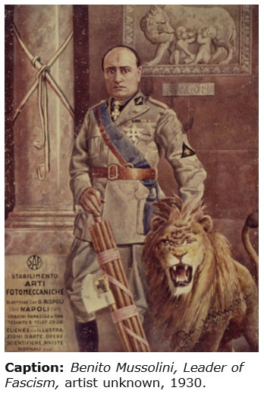
Benito Mussolini (1883–1945) was the first Fascist dictator who came to power during the “interwar” years of the early twentieth century. Like other totalitarian dictators, he realized the power of modern communications to spread propaganda. As soon as he declared his dictatorship in 1925, he immediately put his Fascist Party in charge of the media, law enforcement, industry, and education as part of his goal to establish complete control over the Italian people. Professional communicators—newspaper and magazine writers and editors, filmmakers, graphic artists, radio programmers, speechwriters—no longer had the freedom to shape their own messages. The Fascist Party dictated what could be communicated in the media.

In Fascist Italy, media propaganda was used to spread specific messages about the Fascist government’s policies and initiatives, but one of its main uses was simply to create, transmit, and maintain Mussolini’s image as the supreme leader of his nation. Like other totalitarian dictators, Mussolini and his Fascist Party cultivated a cult leader, a great and charismatic ruler whom the Italian people would be encouraged to “worship.” This dictator would not only save his people from their enemies but also carve an aspirational vision of the nation’s future. This image of Mussolini as Il Duce (“The Leader”) was a large part of Italian Fascist propaganda. In addition to visual media such as posters and documentary films, one of the most effective means of transmitting propaganda was the radio, which could broadcast Il Duce’s distinctive voice into the most isolated homes, making even illiterate people feel connected to their nation’s all-powerful leader.

The poster of Mussolini shows Il Duce holding the fasces, a bundle of rods tied together with an axe. The Fascists adopted the fasces, a symbol of imperial authority in ancient Rome, as their symbol. (The word Fascist comes from the English word fasces as well as from the Italian word fascio, which means “group.”) On the wall behind Mussolini is an image of the mythological founders of Rome, Romulus and Remus—twins who were suckled by a wolf. Also, Mussolini stands next to and controls a lion, a commonly recognized symbol of strength, authority, and courage. Since the Italian Fascists sought to recapture some of Italy’s former greatness, their propaganda repeatedly referenced power and the glories of the ancient Roman Empire.

Please use the information above to answer the questions that follow – answers taken from other sources will not receive credit
Questions for Worksheet: Fascist Propaganda
1. What is propaganda and what is its goal?
Answer: It’s basically a persuasive technique that presents a very absolute biased, message for or against a cause, group, or idea. The major goal of it is to appeal to people’s most basic emotions as an approach to influence public opinion over a very controversial Issue.
2. What are some of the key tools of propaganda and what do they aim to do?
Answer: The major tool of propaganda is censorship.It aims at ensuring that only those in authority’s stance can be transmitted and no any other person’s view.
3. What is censorship and why is it a powerful tool of the propagandist?
Answer: Censorship, It’s a form of propaganda tool that only allows the “official” stance to be transmitted to the intended audience and tends to suppresse all other existing viewpoints. It’s powerful because tends to use some form of dictatorship and threats to scare those with divergent views
4. Interpreting
What is the significance of the engraving of Romulus and Remus in the background and the fasces in the foreground (last paragraph of the article)? What other symbols do you notice? What did the creators of this poster want the Italian people to think about Mussolini?
Answer: It’s significant because it’s a commonly recognized symbol of strength, authority, and courage. Another symbol that can be seen is the sword, and the lion which all represents how powerful that particular leader is.
5. Analyzing
Review the key tools of propaganda mentioned in the first paragraph.
Which of these tools did the creators of this poster use? (explain how they were used in the image)
Answer: Powerful Images,This tool was used to depict how the leader in question is both a caring person and at the same time very powerful.
6. Explaining
a) What might be some advantages of presenting propaganda in a visual form, such as posters and film? b) What media today might be most effective in spreading propaganda to the greatest number of people?
Answer a):Using Images can be so appealing and it leaves along lasting impression in the mind of many people who in one way on another might have had a different view of the leader in question.
Answer b): The most appropriate media to spread propaganda is Twitter .This is because most people have access to it and Information can reach a large audience just on a simple tweet .
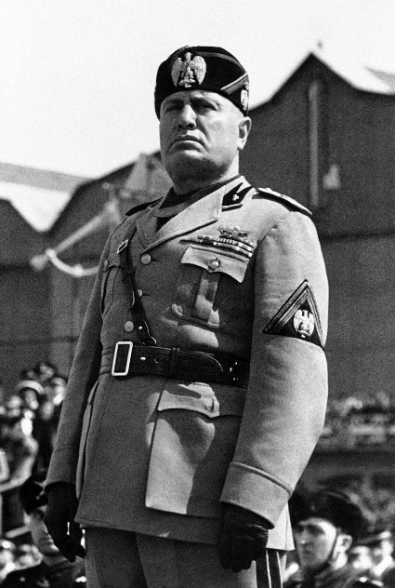
-Worksheet: Benito Mussolini-
Benito Mussolini (1883–1945)
Benito Mussolini was a Fascist dictator and the Italian prime minister from 1922 to 1943. He advocated socialism in his youth but was expelled from the Socialist Party when he supported Italy’s entry into World War I on the Allied side. After the war, Mussolini gained popularity among war veterans, peasants, and others who believed that Italy needed a ruthless dictator in order to revitalize itself. In response to this growing popularity, King Victor Emmanuel III named Mussolini prime minister in 1922. Ruling as a dictator, Mussolini invaded foreign lands, and his apparent successes with Fascism attracted the attention of Adolf Hitler. They formed a Rome–Berlin Axis, which resulted in Mussolini having less control over Italy’s role in World War II.
More About the Image: In this photograph, Mussolini addresses Fascist youth.

Please use the information above to answer the questions below – answers taken from other sources will not receive credit
1. Why did King Victor Emmanuel III name Mussolini prime minister?
Answer: The people of Italy were devoted to Democratic and thus discredited the King and his Liberal Government. A new fear had developed amongst the King and his Government over this, a fear of a Civil War. To protect himself the King had thus used Fascists to protect him and his government. This produced enough evidence for the King to show that Mussolini was able to control a country in order, to make him the Prime Minister of Italy.
2. How did Mussolini and Hitler become allies?
Answer:They became allies through the support that Germany offered to Rome during and after the Abyssinian crisis of the mid-1930s which later turned out that Mussolini had grandiose visions of building a new Italian empire, to replicate the glories of ancient Rome.

-Worksheet: Joseph Stalin-
Joseph Stalin was a Soviet politician and dictator. In 1899, as a seminary student, he was expelled from school for revolutionary activity. He later became a member of an underground revolutionary group and disciple of Vladimir Lenin. After the Bolsheviks rose to power in 1917, Stalin served in many high-ranking positions. He was able to take control of Soviet politics after Lenin’s death in 1924. During this period, he enacted policies and secret executions that took millions of lives. In World War II, he signed a Nonaggression Pact with Germany but later sided with Britain and the United States after Germany invaded Russia in 1941. After World War II, Russia emerged as an industrial and military power. Stalin continued his repressive political measures until his death in 1953.

Please use the information above to answer the questions below – answers taken from other sources will not receive credit
1. Describe Joseph Stalin’s leadership style.
Answer: He was kind of a dictator and he believed in dictatorship.Thus,he managed to rule the Soviet Union for more than two decades.

2. How did Joseph Stalin cause millions of deaths during his time as dictator?
Answer: During his tenure, he enacted policies and secret executions that took millions of lives people for example,In World War II, he signed a Nonaggression Pact with Germany but later sided with Britain and the United States after Germany invaded Russia in 1941.

-Chapter 28 Lesson 3: Hitler and Nazi Germany-
Directions: Locate each heading below in your textbook. Then use the information under the correct heading and subheading to help you write each answer.

A. Hitler and Nazism
1. What was at the core of Hitler’s ideas?
Answer: It included; Racism and nationalism
2. What theory did Hitler emphasize in Mein Kampf?
Answer: Social Darwinian theory of struggle- emphasizes the right of superior nations to living space through expansion.
3. a) How did the economic climate in Germany help the Nazis rise to power? b) When did this occur?
Answer a): Through massive unemployment grey in 1931-1932 as well as economic problems
Answer b): It occurred in between 1931-1932
4. a) What year was the Enabling Act passed? b) How did it give Hitler control of Germany?
Answer a): 1933
Answer b):Got rid of constitution for 4 years, hitter became a dictator and can do whatever he wants now.
5. What did the Nazis do with their new power?
Answer: Got rid of democracy, blamed Jews for everything, set up concentration camps for opposed and got rid of all opposition.
B. The Nazi State, 1933–1939
1. How did Hitler manipulate the term “Aryan” for Nazi purposes?
Answer: By connecting it to ethnicity- identified Aryana with ancient Greeks and Romans and 20th century Germans and Scandinavians.
2. How did Hitler use economic programs and the Schutzstaffeln to strengthen the Nazis’ power in Germany?
Answer: He basically relied on terror to take control- murder, concentration camps. He used FDR public works program to put people back to work. Established massive rearmament program dropping unemployment

3. What were the Nuremberg laws?
Answer: They were basically,two race-based measures that were aimed at depriving Jews of rights and it was designed by Adolf Hitler and approved by the Nazi party.
4. What was Kristallnacht?
Answer: It was an incident in which Nazis in Germany torched synagogues, vandalized Jewish homes, schools and businesses and killed close to 100 Jews.
5. How did the Nazis promote their ideas?
Answer: They used propaganda to influence individuals' attitudes and actions as a way to be able to cultivate public support for their idea.
Summary & Reflection

Directions: Using ideas from throughout the entire lesson, summarize the main ideas by answering the question below. Answers must be IN YOUR OWN WORDS. DO NOT RESEARCH ANSWERS ONLINE! Points awarded based on accuracy and effort.
Using the textbook’s definition of Totalitarian State, and examples provided by the textbook, explain how Nazi Germany met the criteria of this definition (in other words, how did each of these governments attempt to control the 1) the political, 2) the economic, & 3) the social/ intellectual/cultural life of their people).

Must have two specific and detailed examples for each – from the textbook only

Nazi Germany
Attempted to control the political life of its people by using oppression and violence to eliminate Jews

attempted to control the economic life of its people by Introduction of economic policies which had different effects on different groups within the society

attempted to control the social life of its people by influencing the beliefs of young Germans through the Hitler Youth, schools indoctrinated young people in the political and racial ideas of Nazism.

Attempted to control the intellectual/cultural life of its people by setting a clear Idea on what exactly they wanted from women. They were expected to stay at home, look after the family and produce children in order to secure the future of the Aryan race.

-Worksheet: The Message of Nazism-
Background To communicate the message of Nazism, Adolf Hitler used powerful visual symbols displayed prominently at rallies, demonstrations, and mass meetings. The most potent symbol—the swastika—has been adopted by many cultures throughout history as a symbol of good luck, peace, or prosperity. In the early 1900s it became associated with right-wing groups in Germany, which held extreme nationalistic and anti-Semitic views.

Hitler believed his Third Reich was the natural successor to the First Reich (the early Holy Roman Empire) and the Second Reich (the German Empire from 1871 to 1918). The Nazi Party flag paid homage to the past by borrowing the colors of the imperial flag of the Second Reich. As an imperial emblem, the eagle first appeared in the German kingdoms that comprised the First Reich. It adorned the flags of the Holy Roman Empire and later the Second Reich. The Nazis displayed the eagle on badges, on medallions, on stationery, and, most notably, atop monuments and parade standards.

The city of Nuremberg also became a symbol for the Nazi Party. During the late Middle Ages, Nuremberg grew from a fortified German settlement into a thriving center of German culture and learning. Because of its historical significance, Hitler chose Nuremberg for the site of the massive party rallies that eventually became annual events.

Directions: Read the selection and study the poster and its callouts. Then answer the questions. Use prior knowledge and information from your text to provide some answers.

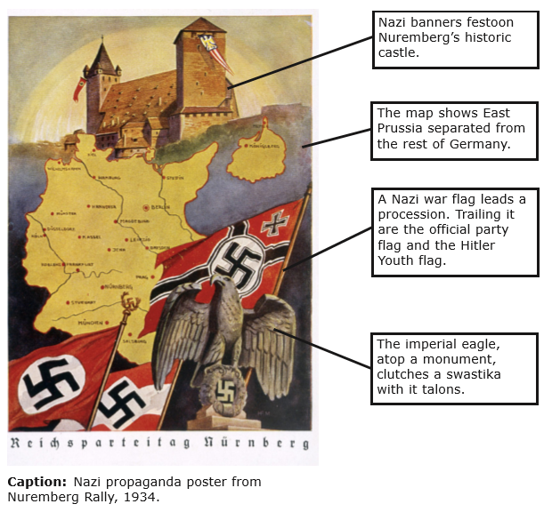
After innumerable trials I decided upon a final form—a flag of red material with a white disc bearing in its centre a black swastika. After many trials I obtained the correct proportions between the dimensions of the flag and of the white central disc, as well as that of the swastika. And this is how it has remained ever since . . . The new flag appeared in public in the midsummer of 1920. It suited our movement admirably, both being new and young. Not a soul had seen this flag before; its effect at that time was something akin to that of a blazing torch. We ourselves experienced almost a boyish delight when one of the ladies of the party who had been entrusted with the making of the flag finally handed it over to us. And a few months later those of us in Munich were in possession of six of these flags. The steadily increasing strength of our hall guards was a main factor in popularizing the symbol. And indeed a symbol it proved to be. Not only because it incorporated those revered colours expressive of our homage to the glorious past and which once brought so much honour to the German nation, but this symbol was also an eloquent expression of the will behind the movement. We National Socialists regarded our flag as being the embodiment of our party programme. The red expressed the social thought underlying the movement. White the national thought. And the swastika signified the mission allotted to us—the struggle for the victory of Aryan mankind and at the same time the triumph of the ideal of creative work which is in itself and always will be anti-Semitic.

—Adolf Hitler,
from Mein Kampf, 1925

Question for: Worksheet the Message of Nazism
1. Analyzing Primary and Secondary Sources
a) Describe the Nazi flag and explain what the elements on it symbolize.
b) To what was Hitler referring when he mentioned “those revered colours expressive of our homage to the glorious past”?
c) Why did he revere this past?
Answer a): Hitler was referring to the colors of the old German flag which were red, black, and white.
Answer b): He revered the past because he regarded old Germany as a powerful and glorious nation
Answer c): He also used the Swastika symbol because of the mystic inclinations of the Nazi army.
2. Analyzing Information: According to the excerpt, why did Hitler believe the swastika embodied anti-Semitism?
Answer: It’s because the swastika flag had a suggestive sense of power and direction.
3. Making Connections
a) What sentiments would the image of the banner-festooned Nuremberg castle inspire in the minds of Germans? b)Why would the map of Germany provoke bitter memories for Germans?
Answer a): The image of the Nuremberg castle and the old map of Germany would be painful as a reminder of the Nazi past.
Answer b): These memories provoke a resentment in the Germans

4. Identifying Central Issues
a) What message might the Nazis have wanted to communicate by including several different Nazi flags on the poster?
b) What message is conveyed by showing the eagle clutching a swastika with its talons?
Answer a): To create a long lasting impression of how powerful the Nazi is.
Answer b): The message conveyed here is that Germany is a powerful and glorious nation

-Worksheet: Lebensraum Expansion-

Closely related to political geography—states’ relations with one another and with the relationships between citizens and governments—is geopolitics, or the analysis of how geography influences international relations. Geopolitics is pertinent when considering the German plan for obtaining Lebensraum, or “living space,” to accommodate the planned expansion of the German empire and the “master race.” Another concept relevant to Lebensraum is the idea of environmental determinism, which says that features of the environment have a direct effect on aspects of human behavior and society.

The idea of Lebensraum originated with Friedrich Ratzel, a German geographer who said the state was like a biological organism and pointed out that a state’s boundaries can expand or contract due to “rational capabilities.” The Nazis later misused this concept as they sought to justify their attempted expansion into the landlocked area of central Eurasia shown in the map below. British political geographer Sir Halford J. Mackinder saw this area, called the heartland or the Pivot Area, as the key to world domination. In the early twentieth century, Mackinder argued that this area had strategic importance as the “World Island” due to the declining importance of sea power as compared to land power. Mackinder saw the role of Britain and the United States as preserving a balance of power between the countries vying for control of the heartland.

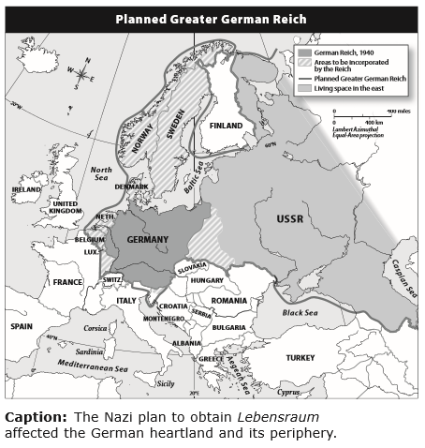
Ratzel’s and Mackinder’s ideas were taken up by German geopolitician Karl Haushofer, who advocated German control of the heartland and its periphery, or outward boundaries. Haushofer also was influenced by the ideas of Rudolf Kjellen, a Swedish political scientist who saw the state as a real organism that had a natural right to grow.

Please use the information above to answer the questions below – answers taken from other sources will not receive credit

Questions for Worksheet: Lebensraum Expansion
1. Interpreting
a) According to the map, in which directions did the Nazis plan to expand their living space?
b) Describe Germany’s projected periphery.
Answer a): East

Answer b): It boarders Italy to the south west and USSR to the east
2. Explaining
Explain how geopolitics influenced the origin and development of the Nazi idea of Lebensraum.
Answer: It advocated for German to have full control of the heartland and its periphery, or outward boundaries.This saw the Nazis later misusing this concept as they sought to justify their attempted expansion into the landlocked area of central Eurasia
3. Drawing Conclusions
Why might control of the heartland be less important today than it was in World War II?
Answer: This is so due to the fact that they world has undergoing drastic changes and heartland is gradually being replaced by the hegemony which is becoming more popular among nations.
4. Making Connections
How is the concept of Lebensraum linked to environmental determinism?
Answer: In order to understand the link that do exist; the society can be collapsed into nature through the concept of Lebensraum. Thus the concept of state was a natural link between people and environment. Although environmental determinism is seen as a relatively new approach its origins go back to the ancient times

-STOP!-
Do not move on to Unit 9 Section 1 until you have completed the Check-in 8.3.

-STOP!-
Do not move on to Unit 9 Section 1 until you have completed the Unit 8 Test.

-STOP!-
Key Assignment is due prior to taking the Unit Test and before moving to the next Unit.

